Creating a RYCOR Guest Account
Use the link below.
https://www.studentquickpay.com/GYPSD/
First Screen you will see. Create account
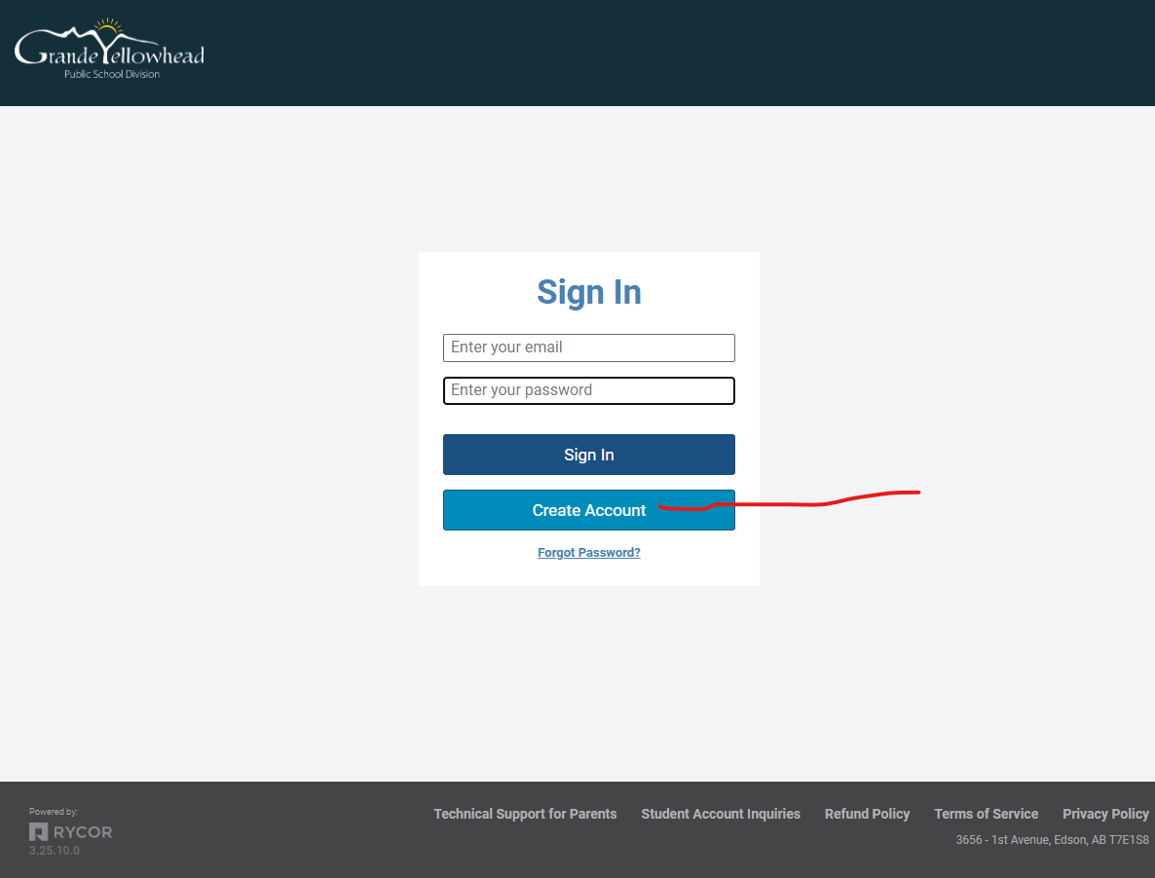

Second Screen fill in all marked and then NEXT

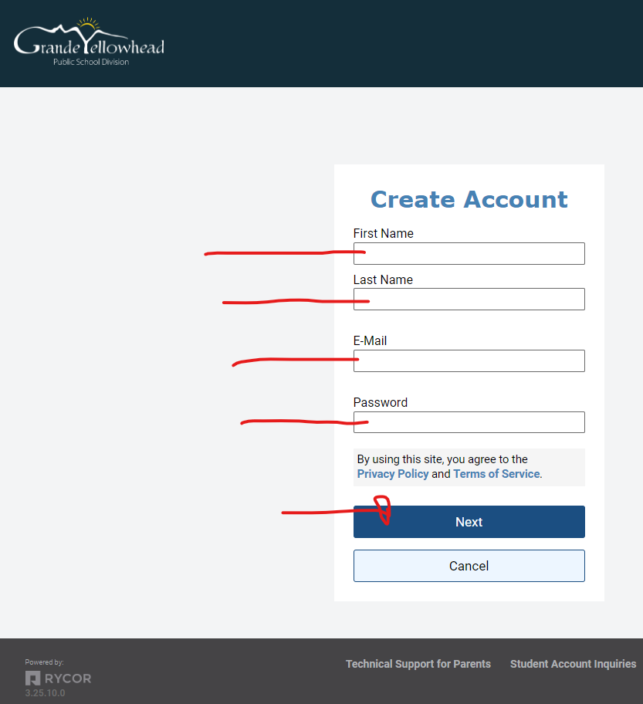

Third Screen click GUEST ACCOUNT and then go to screen # 4

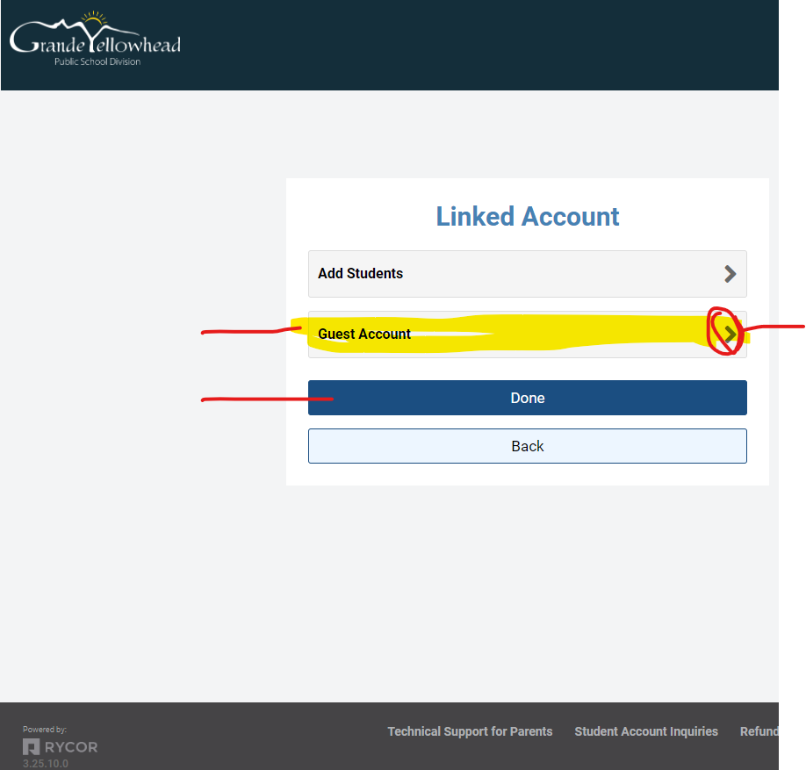

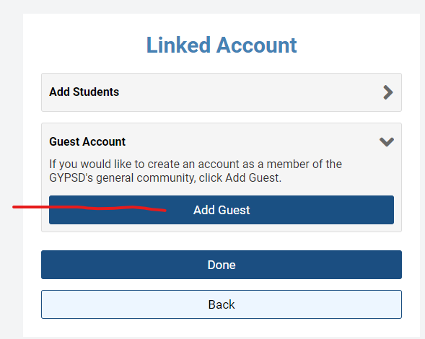

Click ADD GUEST if you would like to maybe use your account again for anything related to the GYPSD
Schools. This will add you as a non-student. Which you can pay for other items in the future that are online purchases.
Then click DONE.

Once done you will see a screen with any available online purchases for GUESTS

For the Paul Stenhouse Scholarship you will see this Item below to click on as a Guest.
Fill in the details and add to your cart to process the payment for this DONATION.
Thanks for your support.

